

CSA0501-DATABASE MANAGEMENT SYSTEMS

LAB EXPERIMENTS DATE: 05/08/2026

EXPERIMENT 15 – DCL COMMANDS: GRANT, REVOKE
AIM: To learn how to use DCL commands such as GRANT and REVOKE.

PROCEDURE:
• Select the pet_management database.
• Create a user for performing DCL operations.
• Grant privileges on the pet_details table to the user.
• Verify the granted privileges.
• Revoke the granted privileges from the user.
• Verify the revoked privileges.
• Confirm successful execution of GRANT and REVOKE commands

PROGRAM:

Create User:

CREATE USER 'petuser'@'localhost' IDENTIFIED BY 'Pet@
- Sub Query:
GRANT SELECT, INSERT ON pet_management.pet_details
TO 'petuser'@'localhost';

3. Sub Query:
SHOW GRANTS FOR 'petuser'@'localhost';

4. Correlated Query:
REVOKE INSERT ON pet_management.pet_details
FROM 'petuser'@'localhost';

5. Check Permissions Again:
SHOW GRANTS FOR 'petuser'@'localhost';

OUTPUT:

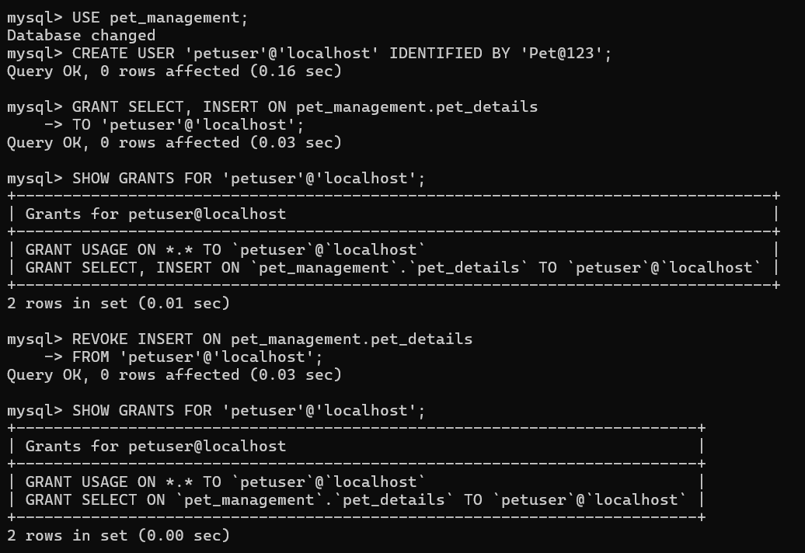

RESULT: The DCL commands GRANT and REVOKE were successfully executed. The privileges granted and revoked on the pet_details table were verified.

